

**SPRING 2019**

**Aspen to Glenwood Springs**

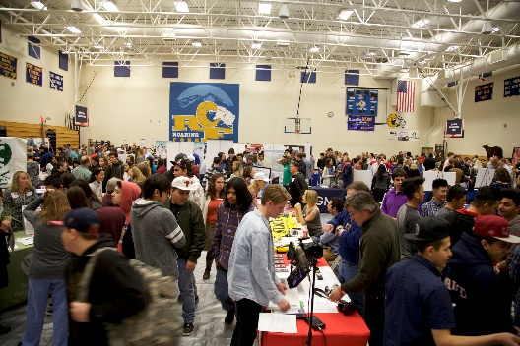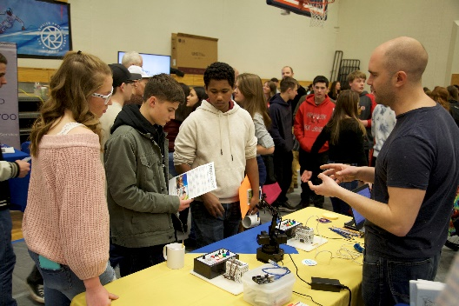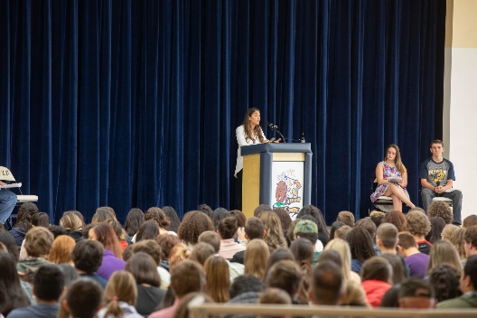

**“Career Makers” Invite You to Explore Your Future**

**Glenwood Springs High School, Glenwood Springs, Colorado**

**Tuesday, March 5, 2019**

**Session 1 9:00 am 10:15 am Glenwood Springs High School**

**Session 2 10:15 am to 11:30 am Basalt & Roaring Fork High Schools**

**Session 3 11:30 am to 12:45 pm Aspen, Bridges & Yampah Mtn. High Schools**

**Session 4 1:15 pm to 2:30 pm Glenwood Springs High School**

**9:00 am to 2:30 pm Career Expo**

***Over 150 Businesses will be at the Expo Talking with Students***

**About GlenX Career Expo**

The GlenX Career Expo was founded on the belief that every high school student needs more opportunities to learn about possible career choices and the post-secondary education they will need

to pursue which can include college, trade/vocational schools, certifications, career-tech training, internships and apprenticeships.

**Our Mission**

To build a stronger, more vibrant community by connecting students to resources that will stimulate their awareness of opportunities and enable them to fulfill their career aspirations for a successful future.

**Our Goals**

* Present an opportunity for high school students to explore a variety of career choices
* Businesses share their career opportunities, experiences and passions directly with students
* Expose high school students to career possibilities through internships, apprenticeships,

career shadowing and summer jobs

*The GlenX Career Expo is brought to you by GlenX*

*in partnership with Aspen Community Foundation*

***More info at*** [***www.glenxcareerexpo.com***](http://www.glenxcareerexpo.com) ***&*** [***www.glenx.tv***](http://www.glenx.tv)